*Florida International University*

*School of Computing and Information Sciences*

Software Engineering Focus

Feature Document

User Story ID #1012

**Name: Decline Invitation**

**Team Member: Alvaro Silva**

**Project: SkillCourt 7.0**

**Product Owner(s)**: Guðmundur Traustason

**Mentor(s)**: Masoud Sadjadi

**Instructor**: Dr. Masoud Sadjadi

**Decline Invitation:**

* Description: **As a** User **I would like** to decline invitations **so that** I reject game invitation from other users.

Acceptance Criteria

* User has an account with SkillCourt
* User is logged in his account
* User was invited by other user

**Use Case**

* Name: Decline Invitation
* Actor: Player
* Preconditions: Actor opened the notification ***and***

System displayed the correct UI

* Description <Flow of events>:

|  |  |
| --- | --- |
| Actor Steps | System Steps |
| 1. Actor clicks the Decline button |  |
|  | 2. System send User to main menu |

**Use Case Diagram** 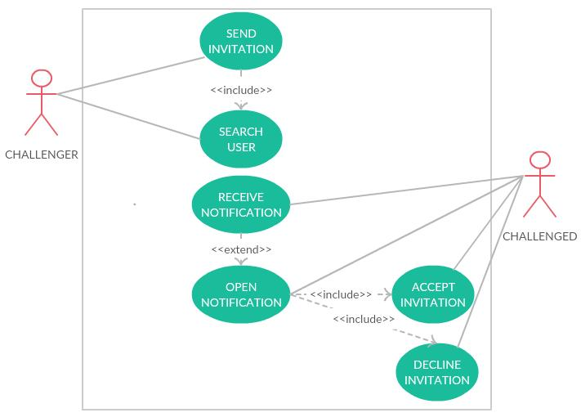

**Sequence Diagram**

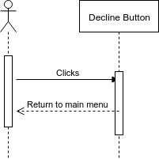

**Unit Test**

* Test case ID:
* Description/Summary of Test: Test if the implementation for rejecting the invitation works
* Pre-condition: SkillCourt app running.
* Expected Results: System opens the main menu.
* Actual Result: System opens main menu and ignore the invitation.
* Status (Fail/Pass): Pass.

**Visual User Guide**

